**What Happened Liber Primus (Post 2014)**

Suggestions (good or bad) for solving the Liber are currently being housed [here](https://uncovering-cicada.fandom.com/wiki/Liber_Primus_Ideas_and_Suggestions)

**A Life Sign**

On May 2nd, 2014 at around 10:00 GMT, 3301 sent out messages to all of the hidden services previously registered on Onion 6. The requests made on the hidden services looked like this:

127.0.0.1 - - [02/May/2014:10:**:** +0200] "GET /key.asc HTTP/1.1" 200 * "-" "Cicada/33.01 CicaDOS 1.033 E Edition"PP

127.0.0.1 - - [02/May/2014:10:**:** +0200] "GET / HTTP/1.1" 200 * "-" "Cicada/33.01 CicaDOS 1.033 E Edition"

127.0.0.1 - - [02/May/2014:11:**:** +0200] "POST /cgi-bin/upload HTTP/1.1" 200 * "-" "Cicada/33.01 Cic/DOS/ 1.033 S Edition"

They requested the public key and and the root before uploading a file named message.txt.asc to the hidden service. The file contained a valid signature and a link to a new onion (ky2khlqdf7qdznac.onion). As it appears, the emails sent to different people were identical.

Content of message.txt.asc: <http://pastebin.com/x4Bm1v6h>

The message:

-----BEGIN PGP SIGNED MESSAGE-----

Hash: SHA1

Hello. Your enlightenment awaits you.

ky2khlqdf7qdznac.onion

We look forward to hearing from you.

Good luck.

3301

-----BEGIN PGP SIGNATURE-----

Version: GnuPG v1.4.11 (GNU/Linux)

iQIcBAEBAgAGBQJTO88vAAoJEBgfAeV6NQkPEfsQAI0jGcmBaQr2AGGr1/ic839I

fc58EyVNLgWs6Aox0/Dc2Tj8dXOxc0sBNWY98tICIy2T0Vbpf1VF65nFs+cVcxXI

pXIU5X0O3XKRfxequIZQQUnt4elLIfFAIgrXbE9N7K5qkD47xg4kaYkPQh7/mDBa

NBVHsLkw8bbLUo7lBtv5VFHTeTikSnT3m7FsoSHl5WlsY9WvITO5VcYd48jFbBSS

P9Uk7v7cg1ohWpDB0BiYUTfOVxXYuZpnFiR6vAADP5KkY/qrFF7wrpYbhSmageId

Qcxyc/dajUTlwK7dl+OwAJn4XRPceBPMjW9SbCr33y1C3ijCuxn06penu0KnUyge

yYjyedXg11UPb/B6eT+hwAOPg/DLDTQ57QOQlGOX19lB56iZbHKuglQZUZ5kJq54

dTobWhi6FBtwu+QLnJCz2SASLCuKDIWFkwSoYro/F9Zlo7b0UUO2IOkcKw7tKzq9

uyPtBDQayCSIIHJhVjAtNiVFjNe+TcBf1VppAGY/7jfUfwxJ7Sfbv5Jwll+6MDYr

YdsnJBZjhLuoxFyr9g4TF0OTXmxT+TyAZ4qoItu4C0bcEncBcfLJz+J74X1upsZl

DMq7On1paQAkXvzr6ywDBpMJbDZETkl9gZbzHn1Ji+9f3fANrqU+5kZ1su2OReQf

++CO13gAUF4WohKip4mC

=VAo/

-----END PGP SIGNATURE-----

The GET request was made by Cicados 'E Edition' and the POST by 'S Edition', E and S are the 5th and 19th letters in the alphabet, with S being 7th letter from the end of the alphabet ie 5 and 7.

The message.asc.txt file is malformed with non-visble ascii spaces in the message that provide a hint in the form of the prime number sequence with the digit 19 missing.

Linked below is a screenshot of the message.asc.txt file so you can see how the numbers are encoded: <http://imgur.com/wayVO26>

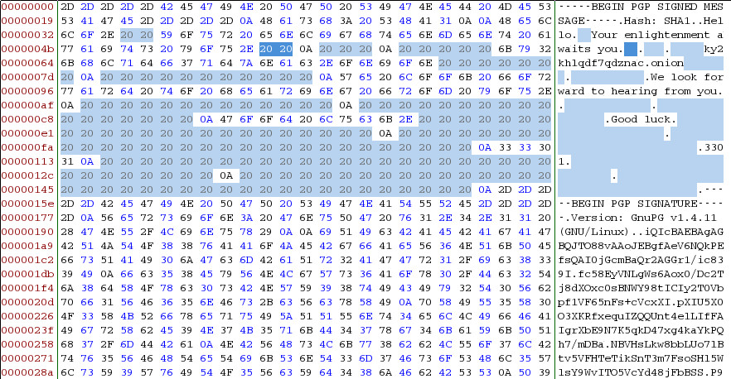

In July 2015, a similar sequence of spaces was found within the PGP signed pastebin message that was published from the Cicada twitter account (<https://twitter.com/1231507051321>). This sequence can be seen here: <http://imgur.com/XtM8Yk9>

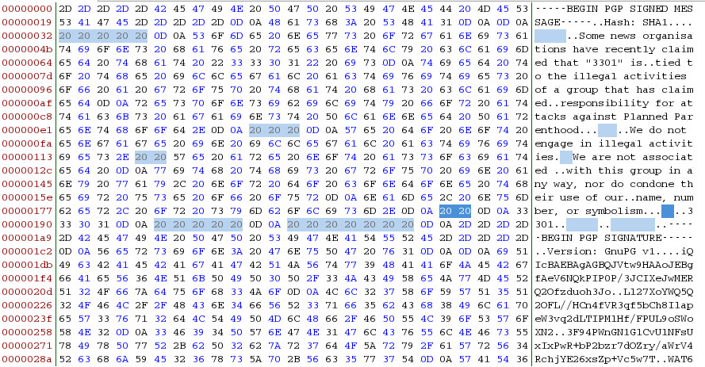

Further discussion on the possible significance of these spaces can be found here:

[Cicada Breaks the Silence: 2015 Twitter Message](https://uncovering-cicada.fandom.com/wiki/Cicada_Breaks_the_Silence:_2015_Twitter_Message)

**Onion 7 - ky2khlqdf7qdznac.onion**

The onion from the message was running a thttpd server, version 2.25b. It was modified on April 2nd 08:33:19 GMT, meaning it took 3301 one month to set the website up and they let us wait another month before finally uploading a message.

Header:

Server: thttpd/2.25b 29dec2003

Last-Modified: Wed, 02 Apr 2014 08:33:19 GMT

Date: Fri, 02 May 2014 11:32:45 GMT

Content-Type: text/html; charset=iso-8859-1

Connection: close

Accept-Ranges: bytes

Requesting a non existent file resulted in a 404 page giving the port used by the server:

Apache Server at 127.0.0.1 Port 5243

Trying to connect to the server with telnet resulted in the following error:

UNKNOWN 400 BaO'[d Request

Server: thttpd/2.25b 29dec2003

Content-Type: text/html; charset=iso-8859-1

Date: Fri, 02 May 2014 11:46:39 GMT

Last-Modified: Fri, 02 May 2014 11:46:39 GMT

Accept-Ranges: bytes

Connection: close

Cache-Control: no-cache,no-store

<HTML>

<HEAD><TITLE>400 Bad Request</TITLE></HEAD>

<BODY BGCOLOR="#cc9999" TEXT="#000000" LINK="#2020ff" VLINK="#4040cc">

< H2>400 Bad Request< /H2>

Your request has bad syntax or is inherently impossible to satisfy.

< HR>

<ADDRESS><A HREF="<http://www.acme.com/software/thttpd/>">thttpd/2.25b 29dec2003</A></ADDRESS>

</BODY>

</HTML>

Source code:

< html >

< head >< title >133</ title ></ head >

< body >

< div id="331" >

< img src="0.jpg" />< br />

< img src="1.jpg" />< br />

< img src="2.jpg" />< br />

< img src="3.jpg" />< br />

< img src="4.jpg" />< br />

< img src="5.jpg" />< br />

< img src="6.jpg" />< br />

< img src="7.jpg" />< br />

< img src="8.jpg" />< br />

< img src="9.jpg" />< br />

< img src="10.jpg" />< br />

< img src="11.jpg" />< br />

< img src="12.jpg" />< br />

< img src="13.jpg" />< br />

< img src="14.jpg" />< br />

< img src="15.jpg" />< br />

< img src="16.jpg" />< br />

< img src="17.jpg" />< br />

< img src="18.jpg" />< br />

< img src="19.jpg" />< br />

< img src="20.jpg" />< br />

< img src="21.jpg" />< br />

< img src="22.jpg" />< br />

< img src="23.jpg" />< br />

< img src="24.jpg" />< br />

< img src="25.jpg" />< br />

< img src="26.jpg" />< br />

< img src="27.jpg" />< br />

< img src="28.jpg" />< br />

< img src="29.jpg" />< br />

< img src="30.jpg" />< br />

< img src="31.jpg" />< br />

< img src="32.jpg" />< br />

< img src="33.jpg" />< br />

< img src="34.jpg" />< br />

< img src="35.jpg" />< br />

< img src="36.jpg" />< br />

< img src="37.jpg" />< br />

< img src="38.jpg" />< br />

< img src="39.jpg" />< br />

< img src="40.jpg" />< br />

< img src="41.jpg" />< br />

< img src="42.jpg" />< br />

< img src="43.jpg" />< br />

< img src="44.jpg" />< br />

< img src="45.jpg" />< br />

< img src="46.jpg" />< br />

< img src="47.jpg" />< br />

< img src="48.jpg" />< br />

< img src="49.jpg" />< br />

< img src="50.jpg" />< br />

< img src="51.jpg" />< br />

< img src="52.jpg" />< br />

< img src="53.jpg" />< br />

< img src="54.jpg" />< br />

< img src="55.jpg" />< br />

< img src="56.jpg" />< br />

< img src="57.jpg" />< br />

</ div >

</ body >

</ html >

The onion contained 58 pages, numbered 0.jpg to 57.jpg, all written in runes and apparently part of the Liber Primus: <http://imgur.com/a/8xnWx#0>

Note: the liber primus is in separate file

**Rune Pages, HTML File and message.txt.asc**

A drop box of all unmodified files is available here:

<http://tinyurl.com/2014onion7>.

<https://github.com/rtkd/iddqd/tree/master/liber-primus__images--unsolved>

<https://github.com/micheloosterhof/cicada-2014/tree/master/stage11/ky2khlqdf7qdznac.onion>

Imgur gallery: <https://imgur.com/a/8xnWx#0>

Transcription of all pages (including previous solved pages): <https://github.com/rtkd/iddqd/blob/master/liber-primus__transcription--full/liber-primus__transcription--full>

Transcription in latin letters (might contain errors): <https://titanpad.com/vFCy7T5p0O>

**Rune Page Sets**

The rune pages appear to be in sets of various length as defined by decorations in their margins and a discussion on their meanings can be found here: [http://archive.4plebs.org/x/thread/14547165/[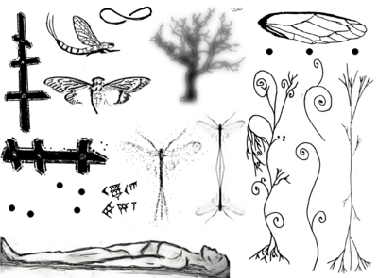](http://uncovering-cicada.wikia.com/wiki/File:1399181864285.png)](http://archive.4plebs.org/x/thread/14547165/)

Several of these symbols are repeated on pages of the Liber Primus received earlier but are reversed (ie the cicada emerging and the reclining man). Some symbols repeat across the page sets and are also similarly transformed by rotation or mirroring (ie the 5 dots and infinity or mobius symbol):

34.jpg to 39.jpg - cuneiform numbers, the Babylonians, sexagesimal numeral system, possible hint to base 60

7.jpg, 23.jpg and 56.jpg - 5 dots in various transformations

24.jpg to 26.jpg, 57.jpg, 14.jpg - Mayflies, Ephemeridae, possible hint to ephemeral cipher

8.jpg to 14.jpg, 32.jpg and 55.jpg - Dendrites in various forms, inverted

It is likely the decorations provide an indication of how to decode the pages within a set or provide a path through the different page sets. This hypothesis is reinforced by adjusting colour levels on the images to reveal what appears to be further information:

<http://imgur.com/a/u2Ir4#0>

**Transcription of Runes**

The runes, in text format, can be found [**here**](http://sprunge.us/RIJZ)

A **numerical transcript** is available here: <https://raw.githubusercontent.com/remlong/cicada-runes/gh-pages/runes.txt> . The runes were numbered 0-28. Each page is on a new line and all spaces and symbols are underscores.

Note: those exists in a separate file

There are some scripts to decrypt runes based in some rules:

**runes.py** <http://git.io/xQrlUg>

**runescript.py** <http://pastebin.com/zXMgSFLM> (which is based in runes.py)

*Transcription was once in progress and can be found*[*here*](http://titanpad.com/vFCy7T5p0O)*.*

**Decryption of page 57 and 58**

**Page 56**

Page 56 was decrypted using a running stream of the Totient function, and a modulo of 29, both things used repeatedly by Cicada so far. For practical purposes, the totient function of a prime is that prime -1. This means to decrypt this page, shift the runes with a stream of (prime numbers, modulo 29) -1 ie 1,2,4,6,10,12,16,18,22,28,1,7,11,13.....Modulo 29 is used because there are 29 runes in the gematria so you only need the remainder of (Prime-1)/29 to determine and simplify the shift.

[Python script](http://sprunge.us/MNiI)

Page 56 decodes to:

AN END: WITHIN THE DEEP WEB TH

ERE EXISTS A PAGE THAT HA

SHES TO:

36367763ab73783c7af284446c

59466b4cd653239a311cb7116

d4618dee09a8425893dc7500b

464fdaf1672d7bef5e891c6e227

4568926a49fb4f45132c2a8b4

IT IS THE DUTY OF EUERY PILGR

IM TO SEEK OUT THIS PAGE.

This could be interpreted as the hash of an onion page, however it should be noted that hashes can be used as unique file identifiers for deep web applications such as Freenet, Gnunet or P2P file sharing systems.

**Possibly an Important Note:** On Page 56, the 57th rune (if counting from 1; 56th if counting from 0), an "F" rune, is skipped over. It is the fourth of five "F" runes on the page and the only one that is not encrypted. If you do not skip it, the prime number 269 would be used (269 Mod 29)-1 = 7. This would result in "OE" instead of "F" and garbled text for the rest of the message. So 269 is not used here, and instead the next rune is shifted using prime number 269.

**Page 57**

Page 57 is not encrypted and can be decoded directly from the Gematria Primus:

Parable : like the instar tunneling to the surface.

We must shed our own circumferences. Find the

divinity within and emerge.

This is Parable 1,595,277,641 which [appeared in 2013](https://uncovering-cicada.fandom.com/wiki/Instar_emergence_(mp3_and_hidden_poem)#Meaning_of_Parable_1.2C595.2C277.2C641) within the ID tag of 761.mp3. The mp3 title is 'The Instar Emergence' which can be summed using the Gematria Primus to obtain '761'. The number 1,595,277,641 is similarly obtained using the product of the gematria sums of each line of the parable ie 1259*1031*1229 = 1,595,277,641.

**Page 49, 50, 51**

These pages  contain the following ASCII text:

3N 3p 2l 36 1b 3v 26 33 1W 49 2a 3g 47 04 33 3W 21 3M 0F 0X 1g 2H 0x 1R 1n 3I 2r 0P 2U 16 2L 2D 1t 1s 3H 0d 0s 1K 2D 05 1K 1O 0S 1D 3o 1l 3J 1G 4D 0G 0l 0x 1Q 2p 2a 1K 4E 1w 2Q 19 1k 3G 24 0p 22 4F 0P 3C 3J 1D 2n 1m 2i 1J 3P 2v 1s 2O 0k 1M 2M 0w 3L 3D 2r 0S 1p 15 3V 3e 3I 0n 3u 1O 0u 0Z 3g 2U 1C 0Y 1N 3n 0W 3Q 22 13 0V 3c 0E 34 0W 1t 1D 2N 3H 47 0s 2p 0Z 34 0g 3v 1Q 0s 0D 0K 2h 3D 3L 2x 1Q 20 2n 2L 1C 2p 0A 29 3r 0D 45 0k 2e 2W 25 3U 1W 2r 46 2s 2X 39 3p 0X 0E 1q 0q 4B 49 48 3r 3b 3C 1M 1j 0I 4A 48 40 3m 4E 0s 2S 1v 3T 0I 3t 2B 2k 2t 2O 0e 2l 1L 28 2a 0J 1L 0c 3C 2o 0X 00 2Z 2d 1T 2u 1t 1j 0l 1o 1E 3T 18 3E 1G 27 0L 0v 2t 06 11 1A 2U 4B 1O 2M 3d 2S 0x 0w 0q 0p 2V 18 0q 1D 49 2O 00 1v 2t 1k 3s 3G 21 3w 0W 29 2r 2O 2L 0g 3Y 0M 0u 3I 3C 1r 2c 2q 3o 30 0a 39 1K

The first digit is always '0', '1', '2' or '3'. The last letter falls within '[0-9A-Za-x]', exactly 60 values. The maximum value is '4F'. This suggests a sexagesimal (base 60) counting system, where '4F' would correspond to '255'.  The text can be rewritten in hexadecimal as follows:



The above does ignore the fact that there is also no 'f' letter in the text. Means that it could also be in base 59.

**Page 49**

Page 49 contains:

3N 3p 2l 36 1b 3v 26 33

1W 49 2a 3g 47 04 33 3W

21 3M 0F 0X 1g 2H 0x 1R

1n 3I 2r 0P 2U 16 2L 2D

1t 1s 3H 0d 0s 1K 2D 05

1K 1O 0S 1D 3o 1l 3J 1G

4D 0G 0l 0x 1Q 2p 2a 1K

4E 1w 2Q 19 1k 3G 24 0p

22 4F 0P 3C 3J 1D 2n 1m

2i 1J 3P 2v 1s 2O 0k 1M

**Page 50**

Page 50 contains:

2M 0w 3L 3D 2r 0S 1p 15

3V 3e 3I 0n 3u 1O 0u 0Z

3g 2U 1C 0Y 1N 3n 0W 3Q

22 13 0V 3c 0E 34 0W 1t

1D 2N 3H 47 0s 2p 0Z 34

0g 3v 1Q 0s 0D 0K 2h 3D

3L 2x 1Q 20 2n 2L 1C 2p

0A 29 3r 0D 45 0k 2e 2W

25 3U 1W 2r 46 2s 2X 39

3p 0X 0E 1q 0q 4B 49 48

3r 3b 3C 1M 1j 0I 4A 48

40 3m 4E 0s 2S 1v 3T 0I

3t 2B 2k 2t 2O 0e 2l 1L

**Page 51**

Page 51 contains:

28 2a 0J 1L 0c 3C 2o 0X

00 2Z 2d 1T 2u 1t 1j 0l

1o 1E 3T 18 3E 1G 27 0L

0v 2t 06 11 1A 2U 4B 1O

2M 3d 2S 0x 0w 0q 0p 2V

18 0q 1D 49 2O 00 1v 2t

1k 3s 3G 21 3w 0W 29 2r

2O 2L 0g 3Y 0M 0u 3I 3C

1r 2c 2q 3o 30 0a 39 1K

**Cicada in 2015**

[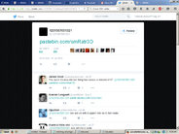](http://uncovering-cicada.wikia.com/wiki/File:Screenshot_2015-11-17_09.35.05.png)In January 2015, to the dissapointment of some, nothing was heard from Cicada. No new puzzle appeared, only a dearth of terrible imitations and troll puzzles. Some theorized it was because the Liber Primus had not been completed, some believed the members they were looking for were enough, or even that 3301 had given up. Regardless of the individual opinions, there was only one public communication from 3301 in this year. Much like their [previous response to accusations of hacking](https://uncovering-cicada.fandom.com/wiki/3301_accused_of_cyberterrorism), 3301 responded similarily to a claim during the Planned Parenthood hack in july that the hacker involved was 3301

### A New Post on Cicada's Twitter Account

At 10:35 P.M. on the 27th of July 2015, Cicada 3301 broke the silence and posted a Pastebin link to their official Twitter account, [@1231507051321:](https://twitter.com/1231507051321)

[10:35 PM - 27 Jul 2015 [Direct Link]](https://twitter.com/1231507051321/status/625902337266204673)

This tweet links to a [message from Cicada 3301 on Pastebin.](http://pastebin.com/smRatr3D)

**2015 "Planned Parenthood" Pastebin Message (Raw Text)**

-----BEGIN PGP SIGNED MESSAGE-----

Hash: SHA1

Some news organisations have recently claimed that "3301" is

tied to the illegal activities of a group that has claimed

responsibility for attacks against Planned Parenthood.

We do not engage in illegal activities. We are not associated

with this group in any way, nor do condone their use of our

name, number, or symbolism.

3301

-----BEGIN PGP SIGNATURE-----

Version: GnuPG v1

iQIcBAEBAgAGBQJVtw9HAAoJEBgfAeV6NQkPIP0P/3JCIXeJwMERQ2Ofzduoh3Jo

Ll27XoYWQ5Q2OFL//HCn4fVR3qf5bCh8IlapeW3vq2dLTIPMlHf/FPUL9oSWoXN2

3F94PWnGN1GlCvUlNFsUxIxPwR+bP2bzr7dOZry/aWrV4RchjYE26xsZp+Vc5w7T

WAT6zX1SA8fhJH4XmJUKsF+7bnIW8TmzUpuHDcYwMGAgwQPoxibprFwY+juJp8KV

ZJOW76rU3F18KhHLbDrFUNwDkXddI7mkf8Nsux+I/Pz0+vqvdFH15nEuv2MORh5w

nYOg3X3duqQ8LLVxmlIIbMIM5hj8I95QnXxebN1bp6yn92RvHqKU++1MyQ1f4ivW

KFeNWAtuF47DTcoadBDVRFLrtcYWYFkcRj913i7bT+Kt3q3pBtdMlP/CAFaO3WwV

fN7jFhTKQIcVGl9RL44CMFCvL1VVUZzT+4SQxLjwSaSfXKN2NF9zbPoWGfx9dHHF

fFulsVTQbBMHYaJhGTa6lkPHlJgbtf0kYsRnNnQ1Rk6zSzGT6l5fvzMi6ahxro+S

zrPAdjLJK5VXYaI/bVD+qZXTMpa4VbETTUDPgpAKvW6aYzuLld4t4v3EbHlDfNyT

XWyqoo3+/JP6VkeSPMyBP4xIdsEiu9jPd0OSmU6UOFPI2OH5zAjdoZ/rqMzvO5pk

aZ3Wu1GK9nmbAhMQPNi+

=77uq

-----END PGP SIGNATURE-----

[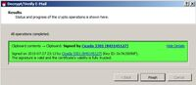](http://uncovering-cicada.wikia.com/wiki/File:Kleogoodpgp.jpg)This message has a PGP signature; checking it against the Cicada 3301 PGP key proves that this message is in fact from Cicada 3301. Therefore, this is the first official message that Cicada 3301 has given us in 2015.

This message was posted shortly after a series of cyberattacks against Planned Parenthood were carried out by a group claiming to be Cicada 3301. This message refutes their claim, and states (once again) that Cicada 3301 is not involved in illegal activities. Soon after this message was released, the group admitted that they were not associated with Cicada 3301 in any way.

This message is modified, but is directly copied from another message which Cicada 3301 released in 2012. There are, however, some unusual differences between the two that are worth mentioning.[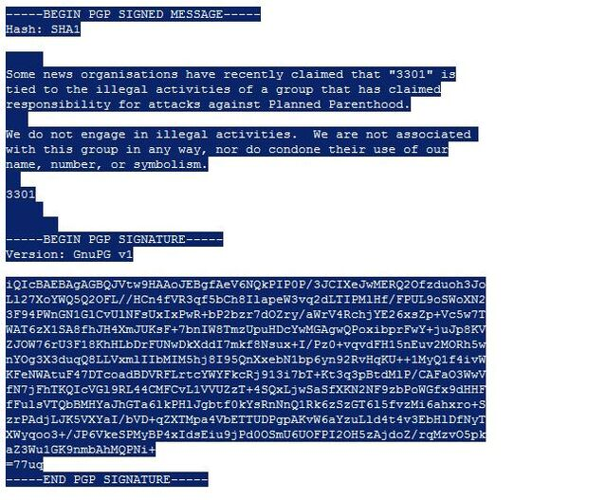](http://uncovering-cicada.wikia.com/wiki/File:Plannedp.jpg)The 2015 "Planned Parenthood" message begins the same way, and uses very similar language. They again use the French "-ise" form for 'organization'. This time, however, 3301 refer to themselves simply as "3301", not "Cicada 3301." On the 7th line of this message, Cicada has omitted/forgotten a 'we': "...nor do [we] condone their use of our name..."

**Sequence of Numbered Spaces in "Planned Parenthood" Message:**

Interestingly, the lines are separated with more than just line breaks in this new message. There is a set of spaces between each paragraph, with a seemingly random number of space characters, before the line is broken and a new paragraph is started.

On the line before the first paragraph is a set of 5 spaces. Between the first and second paragraph is a line with a set of 3 spaces. The second paragraph is followed by a line with a set of 2 spaces. The next line has has the signature "3301", followed by a line with a set of 5 spaces, and ending on a line with a set of 7 spaces.

From the top down, this sequence spells out 5-3-2-5-7, or 53257. Individually, these digits are all prime. When you consider their placement in the message, the numbers 5-3-2 act as spacers between paragraphs, while 5-7 separates the "3301" signature from the end of the message. So you have the numbers 5-3-2 or 532, "3301", and 5-7 or 57. Remember that the rune pages were numbered 0-57, so this may be significant.

**The "message.txt.asc" File From 2014 Rune Pages**

Cicada used sets of spaces to represent numbers in a previous message as well, the [message.asc.txt](https://www.dropbox.com/sh/lkta4q921vliyuw/AABwIBrvR1AcQoTM3abMC3EPa/message.txt.asc?dl=0) file from the unfinished Rune Pages step in 2014 (that link goes to the original file, open it in a text editor like notepad). Most of their other messages and Pastebins are not separated with sets of spaces, but with ordinary line breaks (as in the "Necrome" message.) In the [message.txt.asc](http://pastebin.com/6M3s1FtC)[pastebin version], the spaces were used to represent the prime sequence with an interesting omission. Here is a raw text version of message.txt.asc with the characters highlighted to show the sets of space characters:[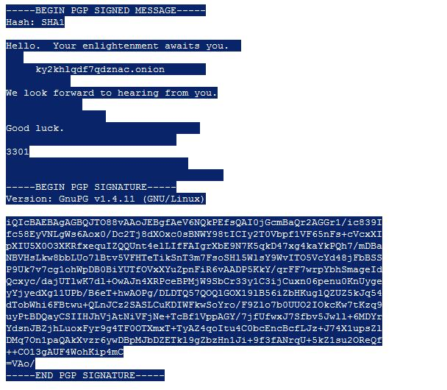](http://uncovering-cicada.wikia.com/wiki/File:Messagetxtasc.jpg)Looking at the image above, we can see that Cicada 3301 used sets of spaces to separate and format this message. This is unnecessary, they could have simply used line breaks. The number of spaces used in each "set" follows the prime sequence, from top to bottom in the message. The number 19, however, is missing from this sequence and nobody could really figure out why it was omitted. Interestingly enough, if 19 were included in this sequence we would have a total of 12 primes. Without it we have 11, which is also a prime.

Below is a comparison of this message to the 2015 "Planned Parenthood" message, which shows these sequences in better detail.

**"message.txt.asc" vs "Planned Parenthood" Message**

Here are the raw text forms of both messages, if you would like to count the number of spaces yourself:

["message.txt.asc"](http://pastebin.com/raw.php?i=6M3s1FtC) (2014)

["Planned Parenthood" Message](http://pastebin.com/raw.php?i=smRatr3D) (2015)

For a better visualization of the numbers being represented, I have replaced the space character sets with crosses(+), and include counts for each set:

**"message.txt.asc" (Spaces Replaced and Counted):**

-----BEGIN PGP SIGNED MESSAGE-----

Hash: SHA1

Hello. Your enlightenment awaits you.++ <----- 2

+++ <------------------------------------------ 3

+++++ky2khlqdf7qdznac.onion+++++++ <----------- 5, 7

+++++++++++ <---------------------------------- 11

We look forward to hearing from you.

+++++++++++++ <-------------------------------- 13

+++++++++++++++++ <---------------------------- 17

Good luck.+++++++++++++++++++++++ <------------ 23

+++++++++++++++++++++++++++++ <---------------- 29

3301

+++++++++++++++++++++++++++++++ <-------------- 31

+++++++++++++++++++++++++++++++++++++ <-------- 37

-----BEGIN PGP SIGNATURE-----

Version: GnuPG v1.4.11 (GNU/Linux)

iQIcBAEBAgAGBQJTO88vAAoJEBgfAeV6NQkPEfsQAI0jGcmBaQr2AGGr1/ic839I

fc58EyVNLgWs6Aox0/Dc2Tj8dXOxc0sBNWY98tICIy2T0Vbpf1VF65nFs+cVcxXI

pXIU5X0O3XKRfxequIZQQUnt4elLIfFAIgrXbE9N7K5qkD47xg4kaYkPQh7/mDBa

NBVHsLkw8bbLUo7lBtv5VFHTeTikSnT3m7FsoSHl5WlsY9WvITO5VcYd48jFbBSS

P9Uk7v7cg1ohWpDB0BiYUTfOVxXYuZpnFiR6vAADP5KkY/qrFF7wrpYbhSmageId

Qcxyc/dajUTlwK7dl+OwAJn4XRPceBPMjW9SbCr33y1C3ijCuxn06penu0KnUyge

yYjyedXg11UPb/B6eT+hwAOPg/DLDTQ57QOQlGOX19lB56iZbHKuglQZUZ5kJq54

dTobWhi6FBtwu+QLnJCz2SASLCuKDIWFkwSoYro/F9Zlo7b0UUO2IOkcKw7tKzq9

uyPtBDQayCSIIHJhVjAtNiVFjNe+TcBf1VppAGY/7jfUfwxJ7Sfbv5Jwll+6MDYr

YdsnJBZjhLuoxFyr9g4TF0OTXmxT+TyAZ4qoItu4C0bcEncBcfLJz+J74X1upsZl

DMq7On1paQAkXvzr6ywDBpMJbDZETkl9gZbzHn1Ji+9f3fANrqU+5kZ1su2OReQf

++CO13gAUF4WohKip4mC

=VAo/

-----END PGP SIGNATURE-----

**"Planned Parenthood" Message (Spaces Replaced and Counted):**

-----BEGIN PGP SIGNED MESSAGE-----

Hash: SHA1

+++++ <--------------------------------------------------------- 5

Some news organisations have recently claimed that "3301" is

tied to the illegal activities of a group that has claimed

responsibility for attacks against Planned Parenthood.

+++ <----------------------------------------------------------- 3

We do not engage in illegal activities. We are not associated

with this group in any way, nor do condone their use of our

name, number, or symbolism.

++ <------------------------------------------------------------ 2

3301

+++++ <--------------------------------------------------------- 5

+++++++ <------------------------------------------------------- 7

-----BEGIN PGP SIGNATURE-----

Version: GnuPG v1

iQIcBAEBAgAGBQJVtw9HAAoJEBgfAeV6NQkPIP0P/3JCIXeJwMERQ2Ofzduoh3Jo

Ll27XoYWQ5Q2OFL//HCn4fVR3qf5bCh8IlapeW3vq2dLTIPMlHf/FPUL9oSWoXN2

3F94PWnGN1GlCvUlNFsUxIxPwR+bP2bzr7dOZry/aWrV4RchjYE26xsZp+Vc5w7T

WAT6zX1SA8fhJH4XmJUKsF+7bnIW8TmzUpuHDcYwMGAgwQPoxibprFwY+juJp8KV

ZJOW76rU3F18KhHLbDrFUNwDkXddI7mkf8Nsux+I/Pz0+vqvdFH15nEuv2MORh5w

nYOg3X3duqQ8LLVxmlIIbMIM5hj8I95QnXxebN1bp6yn92RvHqKU++1MyQ1f4ivW

KFeNWAtuF47DTcoadBDVRFLrtcYWYFkcRj913i7bT+Kt3q3pBtdMlP/CAFaO3WwV

fN7jFhTKQIcVGl9RL44CMFCvL1VVUZzT+4SQxLjwSaSfXKN2NF9zbPoWGfx9dHHF

fFulsVTQbBMHYaJhGTa6lkPHlJgbtf0kYsRnNnQ1Rk6zSzGT6l5fvzMi6ahxro+S

zrPAdjLJK5VXYaI/bVD+qZXTMpa4VbETTUDPgpAKvW6aYzuLld4t4v3EbHlDfNyT

XWyqoo3+/JP6VkeSPMyBP4xIdsEiu9jPd0OSmU6UOFPI2OH5zAjdoZ/rqMzvO5pk

aZ3Wu1GK9nmbAhMQPNi+

=77uq

-----END PGP SIGNATURE-----

**Cicada in 2016**

Again in January of 2016, solvers found no new puzzle awaiting them at the start of January. This time, there was a message however. An image posted interestingly to Infotomb, a site that had been set up by a solver in previous years, originally to answer the question of how to send images while maintaining steganographic qualities of them.

[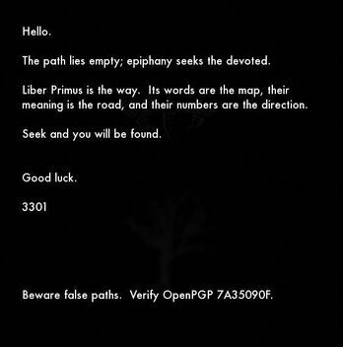](http://uncovering-cicada.wikia.com/wiki/File:4gq25.jpg)The image, shown below, encouraged solvers not only to look back to the unfinished Liber Primus, but also to stop getting distracted by the imitations and fakes that always arise. This was during a time that a very large number of the new, inexperienced or even foolish users were following a long trail devoid of any sort of verifiable evidence of Cicada.

Cicada's Twitter Account: <https://twitter.com/1231507051321>

Cicada twitter posted <https://twitter.com/1231507051321/status/684596461628223488> which leads to the image on the left.

***Important note:****What was believed to be a "dendrite" is actually an oak tree, as revealed by a Google search for "dead oak tree clipart". (*[*http://www.clipartbest.com/cliparts/abc/y97/abcy97qTL.jpeg*](http://www.clipartbest.com/cliparts/abc/y97/abcy97qTL.jpeg)*)*

* Please note, the blocks in the background are noise from the image compression, not a QR code.
* The image size is 563 x 569 (both primes).

When outguessed, the image contains the same text, signed to prove validity. The Tree shown in the background of some pages of the Liber Primus was placed with the cicada in the background of the image, likely to indicate a starting point to solvers.

-----BEGIN PGP SIGNED MESSAGE-----

Hash: SHA1

Hello.

The path lies empty; epiphany seeks the devoted.

Liber Primus is the way. Its words are the map, their

meaning is the road, and their numbers are the direction.

Seek and you will be found.

Good luck.

3301

Beware false paths. Verify OpenPGP 7A35090F.

-----BEGIN PGP SIGNATURE-----

Version: GnuPG v1

iQIcBAEBAgAGBQJWhcHDAAoJEBgfAeV6NQkP8GUP/iDXI/9lqvu/HTCujpPcIgYJ

H0Z8FdHDjz86A9yeyXYEUwPu1cLjSNUyGLBlu5dXuGpakuVeHtHnocuwrY24E2o4

Bnaqd1U8hUVU4Y68Va+jRIKS2NrPwg+HFFHr44DHKLHBM4CRqhLBFin36CeUIWmi

jykPMWwrLgxLy8FNXHvN/Fxqt0dbZ6/g1pxM2XOVEvy8bW/Xj7rj3VJGFOL7YVmM

Lae2PuCbmLZD/gaIhbGcPG7NEyUpFBbKEZ6Ul5i5LMeaRgS6KJHwLykeYdGWn65v

j8uY8+5zLBYus/OdbAZiiY6FnOgU/ESRQChQZILxiUIVT/OtFjz5IHrcVg3otoHl

tVfnSvqEk/AJ+w/MscTIBdxLPuvHmYD1B1XK/uZCRP/Dby6x8NFAR/zKAsqzkTY7

E4m34JzcPdsTnla0zmnz/O90jijfH+QAogyZSuEpdJIJlyFSzvDwhDme55gIAC0x

E1W7mxiOdss+Ebbmyyv4ul+l0UCB3qzfLw2Vijxmw/nWoDRqKk6kJf9vWL05BRu9

RoAap3rh0AC7SCV3fHjQj5VOUEJzHoz4YzrK15sa7SOZfeiP6XpfdzZfesiAWI8x

MUiyTFIqCeWZWJoSIe/1yFtumTkXO8/Dn0SCx9D4R6DVSiM9PRSdYgzT/+oRlIEl

Y8f7hrgdyn31uqGUgV4q

=sKXT

-----END PGP SIGNATURE-----

That's currently the end. The solvers have returned to their attempts on the Liber Primus, but it remains almost 2 years since a page was decrypted. Feel free to come join us in #cicadasolvers on Freenode to discuss any further.